# Analysis and Evaluation

## Analysis of Experiments

EDTA Titration

The aim of the EDTA titration was to measure the concentration of each water sample effectively using the complexometric titration method in turn gain concordant results. This reaction was completed by titrating each water sample with disodium Ethylenediaminetetraacetic acid or more commonly called EDTA. The EDTA bonds entirely to one atom of calcium and magnesium displacing the indicator meaning that the amount of magnesium and calcium in a water sample can be calculated as the end point of the reaction is noted by the change in colour from dark red to dark blue.

Here are the results of the experiment:

Recycled Rain Water

|  |  |  |  |  |  |
| --- | --- | --- | --- | --- | --- |
|  | Trial | 1 | 2 | 3 | 4 |
| Initial Burette reading/cm3 | 25.6 | 34 | 0 | 10.3 | 19.4 |
| Final Burette reading/cm3 | 34 | 43.9 | 10.3 | 19.4 | 29 |
| Volume of EDTA solution used/cm3 | 8.4 | 9.9 | 10.3 | 9.1 | 9.6 |
| Average volume of EDTA 0.01M solution/cm3 | | | | 9.46 | |

Bottled Water (Highland Spring- Still)

|  |  |  |  |  |  |
| --- | --- | --- | --- | --- | --- |
|  | Trial | 1 | 2 | 3 | 4 |
| Initial Burette reading/cm3 | 21.7 | 34.2 | 0 | 15.8 | 31.3 |
| Final Burette reading/cm3 | 34.2 | 49 | 15.8 | 31.3 | 45.4 |
| Volume of EDTA solution used/cm3 | 12.5 | 14.8 | 15.8 | 15.5 | 14.1 |
| Average volume of EDTA 0.01M solution/cm3 | | | | 14.54 | |

Tap Water

|  |  |  |  |  |  |
| --- | --- | --- | --- | --- | --- |
|  | Trial | 1 | 2 | 3 | 4 |
| Initial Burette reading/cm3 | 28 | 31.4 | 35.3 | 38.7 | 42.3 |
| Final Burette reading/cm3 | 31.4 | 35.3 | 38.7 | 42.3 | 46.9 |
| Volume of EDTA solution used/cm3 | 3.4 | 3.9 | 3.4 | 3.6 | 4.6 |
| Average volume of EDTA 0.01M solution/cm3 | | | | 3.78 | |

Pond Water

|  |  |  |  |  |  |
| --- | --- | --- | --- | --- | --- |
|  | Trial | 1 | 2 | 3 | 4 |
| Initial Burette reading/cm3 | 23.3 | 30.4 | 38.2 | 0.1 | 7.3 |
| Final Burette reading/cm3 | 30.4 | 38.2 | 44.9 | 7.3 | 14.6 |
| Volume of EDTA solution used/cm3 | 7.1 | 7.8 | 6.7 | 7.2 | 7.3 |
| Average volume of EDTA 0.01M solution/cm3 | | | | 7.22 | |

Calculations

RECYCLED RAIN WATER

Moles =C x V

=0.01 x 9.46

=0.0946

1:1 ratio

Mass = Mr x Moles

= 40 x 0.0946

=3.784g

3784 mg per 100dm3

Or 37.84mgdm-3

BOTTLED WATER

Moles =C x V

=0.01 x 14.54

=0.1454

1:1 ratio

Mass = Mr x Moles

= 40 x 0.1454

=5.816g

5816mg per 100 dm3

Or 58.16mgdm-3

TAP WATER

Moles =C x V

=0.01 x 3.78

=0.0378

1:1 ratio

Mass = Mr x Moles

= 40 x 0.0378

=1.512g

1492 mg per 100dm3

Or 15.12mgdm-3

POND WATER

Moles =C x V

=0.01 x 7.22

=0.0722

1:1 ratio

Mass = Mr x Moles

= 40 x 0.0722

=2.888g

2888 mg per 100dm3

Or 28.88mgdm-3

I used four different water samples which were:

* Bottled water- More specifically Highland Spring that I bought from a variety of shops.
* Recycled Rain water- Which was supplied to the chemistry laboratories from a filtration system on the roof of the building.
* Tap Water- Gained from the municipal water supply.
* Pond water- Gained from a small man-made pond in the 6th form garden, which has a filtration system.

|  |  |  |
| --- | --- | --- |
| WATER SAMPLE | CONCENTRATION OF Ca2+ IONS |  |
| Tap Water | 15.12 mgdm-3 | Softest |
| Pond Water | 28.88 mgdm-3 |  |
| Recycled rain | 37.84 mgdm-3 |  |
| Bottled Water (Highland spring) | 58.16 mgdm-3 | Hardest |

Explanation of results

My results suggest that bottled water was technically the hardest water which is expected. This is because it has been allowed to experience more lakes and rivers so that more minerals can enter the water. The water in highland spring is collected from the Ochil Hills in Perthshire[1] which is a small mountain range with around 40 summits located in Scotland[2]. The water in highland spring contains so many minerals because it is collected reasonably low down the mountains giving water time to collect minerals. A high mineral level is considered optimal because a high mineral level will improve the taste of the water and it is also beneficial to the needs of the body.

Recycled Rain water was the second hardest which was not concordant in my opinion because I would have thought that rain water would be the softest having no dissolved solids. However the hardness in fact comes from the purifying process

The pond water was the second softest water sample which to me seemed illogical because I would have predicted that the water ordinated either from the municipal supply or rain water which are both soft waters. However, the pond contained fish and to meet the needs of the aquatic life[3] the carbonate hardness would have been altered. Carbonate Hardness or Alkalinity is caused by the presence of carbonate (CO32-) and bicarbonate (HCO3-) anions which the multivalent cations such as Calcium and Magnesium would have been bonded to. This means that temporary hardness would have been increased as temporary hardness and carbonate hardness are at a positive correlation. The Carbonate hardness is increased so that the water can buffer acidities better and not caused harm to the fish.

The softest according to my results was the tap water from the municipal water supply which originates from aqueducts such as the Thirlmere aqueduct and Haweswater aqueduct which supplies water to Manchester. Thirlmere, Haweswater and other leading reservoirs are upland surface water reservoirs meaning they are quite high up. Water has little chance of dissolving minerals because water is collected so high up as opposed to letting the water stream downhill on rocks as such collecting minerals.

Addition of Sodium Carbonate

The aim of this experiment was to determine the effectiveness of the addition of washing soda on the hardness of the water through the use of the EDTA titration. Sodium carbonate has water softening properties. The addition of sodium carbonate softens the water because initially when the sodium carbonate is added it dissolved and dissociates.

Na₂CO₃(s) → 2 Na⁺(aq) + CO₃²⁻(aq)

The carbonate ions are now free in the water and are attracted to the Calcium and Magnesium ions, Carbonates of Magnesium and Calcium are insoluble in water so there are now floating deposits of MgCO₃ and CaCO₃

Mg²⁺(aq) + CO₃²⁻(aq) ' MgCO₃(s)

These insoluble carbonates were not picked up by the EDTA titration because it could not form a complex with the metal ion within the compound. This is why the reading from the titration was lowered.

0.5g Sodium Carbonate

|  |  |  |  |  |
| --- | --- | --- | --- | --- |
|  | Trial | 1 | 2 | 3 |
| Initial Burette reading/cm3 | 0.2 | 6.9 | 12.8 | 19.2 |
| Final Burette reading/cm3 | 6.9 | 12.8 | 19.2 | 26.3 |
| Volume of EDTA solution used/cm3 | 6.7 | 5.9 | 6.4 | 7.1 |
| Average volume of EDTA 0.01M solution/cm3 | | | | 6.525 |

1g Sodium Carbonate

|  |  |  |  |  |
| --- | --- | --- | --- | --- |
|  | Trial | 1 | 2 | 3 |
| Initial Burette reading/cm3 | 3.8 | 9.1 | 12.3 | 16.6 |
| Final Burette reading/cm3 | 9.1 | 12.3 | 16.6 | 21.2 |
| Volume of EDTA solution used/cm3 | 5.3 | 3.2 | 4.3 | 4.6 |
| Average volume of EDTA 0.01M solution/cm3 | | | | 4.35 |

1.5g Sodium Carbonate

|  |  |  |  |  |
| --- | --- | --- | --- | --- |
|  | Trial | 1 | 2 | 3 |
| Initial Burette reading/cm3 | 15 | 19.1 | 26 | 30.9 |
| Final Burette reading/cm3 | 19.1 | 23.1 | 30.9 | 36.4 |
| Volume of EDTA solution used/cm3 | 4.1 | 4 | 4.9 | 4.9 |
| Average volume of EDTA 0.01M solution/cm3 | | | | 4.475 |

2g Sodium Carbonate

|  |  |  |  |  |
| --- | --- | --- | --- | --- |
|  | Trial | 1 | 2 | 3 |
| Initial Burette reading/cm3 | 36.4 | 0 | 3.1 | 7 |
| Final Burette reading/cm3 | 39.7 | 3.1 | 7 | 10.6 |
| Volume of EDTA solution used/cm3 | 3.3 | 3.1 | 3.9 | 3.6 |
| Average volume of EDTA 0.01M solution/cm3 | | | | 3.475 |

Calculations

0.5g SODIUM CARBONATE ADDED

Moles =C x V

=0.01 x 6.525

=0.06525

1:1 ratio

Mass = Mr x Moles

= 40 x 0.06525

=2.61g

2610 mg per 100dm3

Or 26.10mgdm-3

1.0g SODIUM CARBONATE ADDED

Moles =C x V

=0.01 x 4.35

=0.0435

1:1 ratio

Mass = Mr x Moles

= 40 x 0.0435

=1.74g

1740mg per 100dm3

Or 17.4mgdm-3

1.5g SODIUM CARBONATE ADDED

Moles =C x V

=0.01 x 4.475

=0.04475

1:1 ratio

Mass = Mr x Moles

= 40 x 0.04475

=1.79g

1790mg per 100dm3

Or 17.9mgdm-3

2.0g SODIUM CARBONATE ADDED

Moles =C x V

=0.01 x 3.475

=0.03475

1:1 ratio

Mass = Mr x Moles

= 40 x 0.03475

=1.39g

1390 mg per 100dm3

Or 13.9mgdm-3

For this experiment recycled rain water was used firstly because it was one of the hardest water samples which would allow for a greater decrease in Calcium and Magnesium ions. Secondly the water is easy and inexpensive to obtain in comparison to highland spring water as there is a tap in the chemistry lab. The original concentration of multivalent cations was 37.84mgdm-3 and for each addition of sodium carbonate this has been reduced.

|  |  |  |
| --- | --- | --- |
| AMOUNT ADDED | CONCENTRATION AFTER | REDUCTION IN CONCENTRATION |
| 0.5g of Sodium Carbonate added | 26.1 mgdm-3 | 11.74 mgdm-3 |
| 1g of Sodium Carbonate added | 17.4 mgdm-3 | 20.44 mgdm-3 |
| 1.5g of Sodium Carbonate added | 17.9 mgdm-3 | 19.94 mgdm-3 |
| 2g of Sodium Carbonate added | 13.9 mgdm-3 | 23.94 mgdm-3 |

From the results you can see that there is a positive correlation between the addition of sodium carbonate and the concentration of calcium and magnesium ions reduced.

Detergent Effect on Surface tension

|  |  |  |
| --- | --- | --- |
| Water Sample | Hardness of sample | Observation |
| Tap | 15.12mgdm-3 | Was able to hold one spatula of powdered carbon before significant amounts began to fall. |
| Bottled | 58.16 mgdm-3 | Was able to hold around 5 spatulas of powdered carbon before significant amounts began to fall. |
| Recycled | 37.84mgdm-3 | Was able to hold around 4 spatulas of powdered carbon before significant amounts began to fall. |
| Pond | 28.88mgdm-3 | Was able to hold 2 spatulas of powdered carbon before significant amounts began to fall. |

From this experiment I made three observations which were:

1. The amount of powdered carbon each sample could hold and the general hardness were at a positive correlation. This means general hardness (being Ca2+ and Mg2+ions) cause surfactant properties within water. The harder water solutions held a larger amount of powdered carbon because they contain more multivalent cations which will increase the intermolecular forces within the water and therefore will have a higher surface tension
2. The detergent and soap solutions destroyed any surfactant properties that the water held; this was slightly obvious because this wetting agent property is what detergents are used for. When a detergent is added the carbon chain group repels the water and the ionic group attracts the water, this affect reduces the intermolecular forces within the water molecule and consequently the surface tension so that the water molecules are spread more evenly.
3. Detergent solution and soap solution were reasonably similar at dispersing the powdered carbon that was balanced on top of the water.

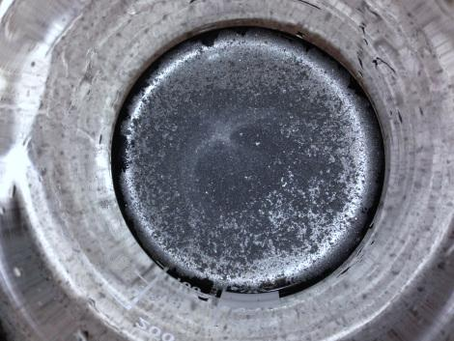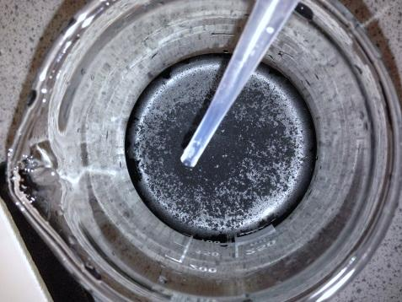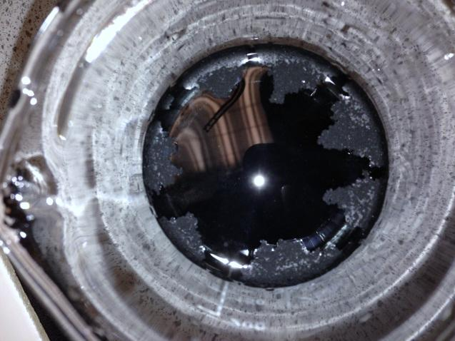

Figures 16-18 these are images before and after the soap solution was added to the water, this water sample was bottled water and was able to hold a large amount of powdered carbon. The pictures were taken before the soap solution was added and after it was added and as you can see the carbon fell to the bottom because of its addition. This is because the detergent destroyed the surfactant properties within the water and therefore it couldn’t then hold the powdered carbon anymore.

## Evaluation of Experiments

EVALUATION OF PROCEDURES

**Complexometric titration**- I chose this method firstly because it was suggested to me and secondly it was the best method for measuring water hardness. Alternate methods of measuring included LC-MS which required very specialized equipment which I could never get hold of. I needed to test this method so that I could later go on to test the effectiveness of the addition of sodium carbonate.

**Addition of Sodium Carbonate**- This method is common within the household as sodium carbonate is more commonly known as washing soda which is used to soften water every day. I decided that I would focus on more household methods because industrial require more specialized equipment.

**Detergent effect on waters surfactant properties** – Water softening methods are often not necessary for domestic purposes because of detergents. This procedure was done to investigate another softening technique used within the household which is the use of detergents as wetting agents.

ADVANCEMENTS- What would I have done if I had more time?

**Boiling method-** This method was simply and easy to do I would have liked to measure its effectiveness.

EDTA titration

EVALUATION OF EQUIPMENT AND CHEMICALS

**Indicator**- A many number of complexometric indicators could be used in this experiment instead of Solochrome Black T. A complexometric indicator is described as a dye that undergoes a definite color change in presence of specific metal ions. It forms a weak complex with the ions present in the solution, which has a significantly different color from the form existing outside the complex. A few examples include Calmagite, Calcein, Curcumin, and Fast Sulphon Black. However these are mainly used for other metal ions such as aluminum and copper.

Calmagite indicator was the next alternative to solochrome black T. Calmagite has two -OH groups with acidic protons. The color of Calmagite changes depending on whether or not these protons are present. At pH=10 one proton is present and the color of the indicator is blue. A calcium or magnesium ion can displace both protons to form a Calmagite-metal complex, which has a red color. Ca2+ and Mg2+ can be titrated using EDTA as the titrant and Calmagite indicator because the EDTA binds Ca2+ and Mg2+ more strongly than the indicator. At the endpoint, the EDTA will bind all of the metal, leaving the Calmagite with no metal ions. A solution containing Calmagite will turn from red (or purple very near the endpoint) to blue.

**pH**- The pH could be changed by using a different buffer solutions. The pH has great effect on the results because the acid-base properties of the EDTA ligand will cause the reaction to be very dependent on pH. The pH determines how protonated the molecule will be, at low pH the molecule will be fully protonated H6Y+2 and at very high pH the molecule is fully deprotonated Y-4.

LIMITATIONS

**Time Scale-** There was a limit upon time scale as we only had a certain amount of practical time, this means not all experiments could be completed.

**Equipment-** Some potential procedures required specialist equipment such as a mass spectrometry machine and HPLC columns which I could not gain access to.

**Access to water sources –**I wanted to collect water from major cities in Britain and then plot my finding on a map. As I had a very strict time schedule I could not collect the water samples from each city.

Addition of Sodium Carbonate

There is an anomalous result between 1g addition and 1.5g addition where instead of following the pattern and increasing the number of ions removed from the water decreases slightly from 20.44mgdm-3 to 19.94mgdm-3. This break in concordance could be due to the 1g addition result being too high, 1.5g result being too low or a combination of both. The reason for these results being off could be due to a number of reasons, all of which are human error:

* Misreading volumes from the burette can cause errors. Usually this is caused by reading off whilst looking at an angle or insufficient light conditions.
* Contamination of glassware and equipment for example when two different solutions are transferred using the same pipette and pipette is not rinsed in between. If glass was not properly cleaned before use it may be contaminated with old reagents, which can react with new ones, changing their concentration.
* Using too much indicator can cause an exceptionally dark colouration making it very hard to spot an end point of a reaction. Indicator must be used sparingly to ensure the colour doesn’t go too dark.
* Misjudging the end point of the reaction colour changes may be very slight and hard to see; solutions need to be added slowly so excess isn’t added.
* When using the scales the weighting boat must be placed on first then zeroed or the mass of the weighing boat will be counted in the reading. Secondly nothing must be near the scales or an improper reading could be gained.

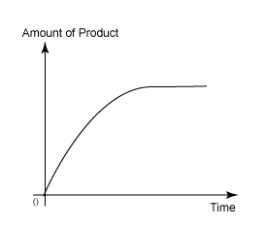

If the experiment was done for a many number of times for of amounts sodium carbonate, the curve should show a similar pattern to this with the effectiveness reducing as the amount of sodium carbonate added increasing. Similar to enzyme-substrate graphs the graph starts of first order then goes to zero order as the water becomes softened and all calcium and magnesium ions have been reacted.

Detergent Effect on Surface tension

# ENDNOTES

1. <http://www.highland-spring.com/our-water/about-us/> 12/01/2014
2. <http://en.wikipedia.org/wiki/Ochil_Hills> 12/01/2014
3. <http://en.wikipedia.org/wiki/Carbonate_hardness> 13/10/2014